EXPERIMENT 1
Convert Image to Grayscale

Aim
To read an image using Python and OpenCV and convert the image into grayscale.

Procedure
- Import the OpenCV library.
- Read the input image using cv2.imread().
- Convert the color image into grayscale using cv2.cvtColor().
- Display the original and grayscale images using cv2.imshow().
- Wait for a key press and close the image windows.

Program
import cv2
img=cv2.imread(r"C:\Users\Amrita\Desktop\image\Screenshot 2026-09-30 143819.png")
gray = cv2.cvtColor(img, cv2.COLOR_BGR2GRAY)
cv2.imshow("Original Image", img)
cv2.imshow("Gray Image", gray)
cv2.waitKey(0)
cv2.destroyAllWindows()

Input
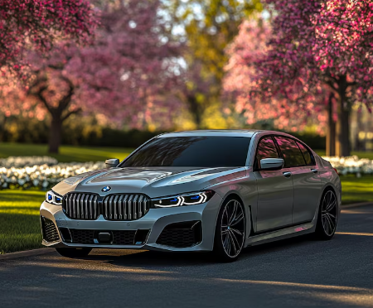

Output
- Original color image
- Grayscale image
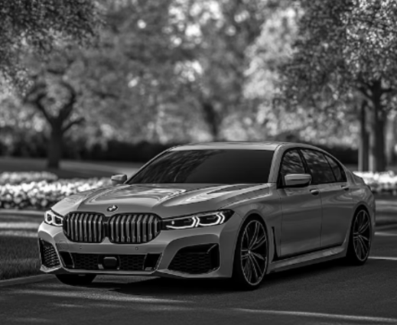
Result
Thus, the given color image was successfully read and converted into a grayscale image using OpenCV.

